<https://openai.com/agent-platform/>

<https://openai.github.io/openai-agents-python/agents/> // documentation

<https://chatkit.studio/playground> // chatkit

<https://platform.openai.com/agent-builder>

<https://github.com/openai/openai-chatkit-starter-app/tree/main/chatkit>

we can run chatkit in local

ps aux | grep streamlit

kill -9 <PID>

My Questions:

1. Develop a agent so that it should shows all the capabilities or features?
2. If I use the Agent SDK, Is it possible all these? Only with agent designer ?
   1. Only with Agent designer, you can see otherwise, you can need to develop your own

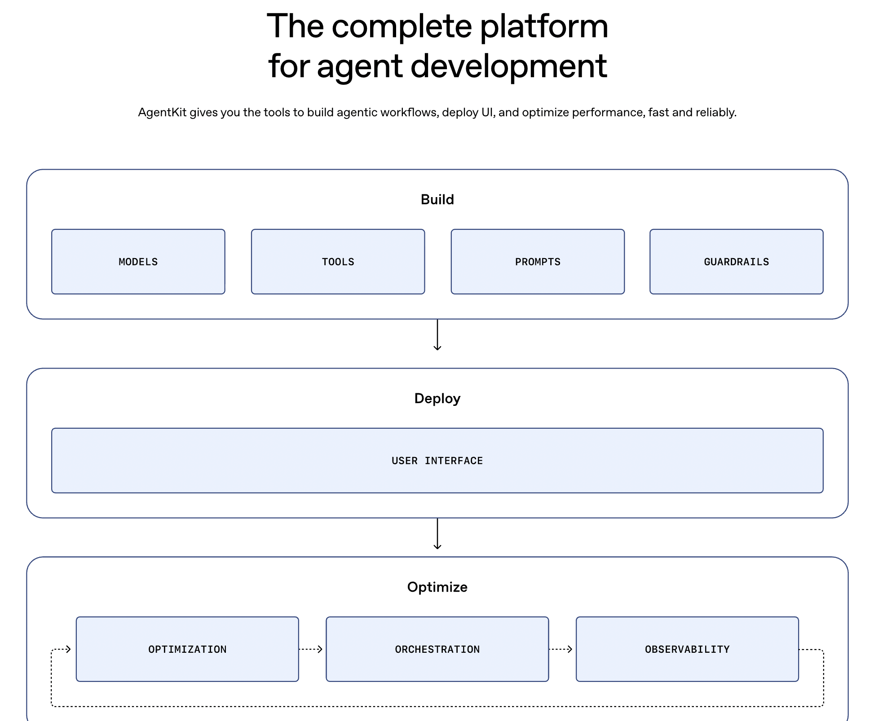

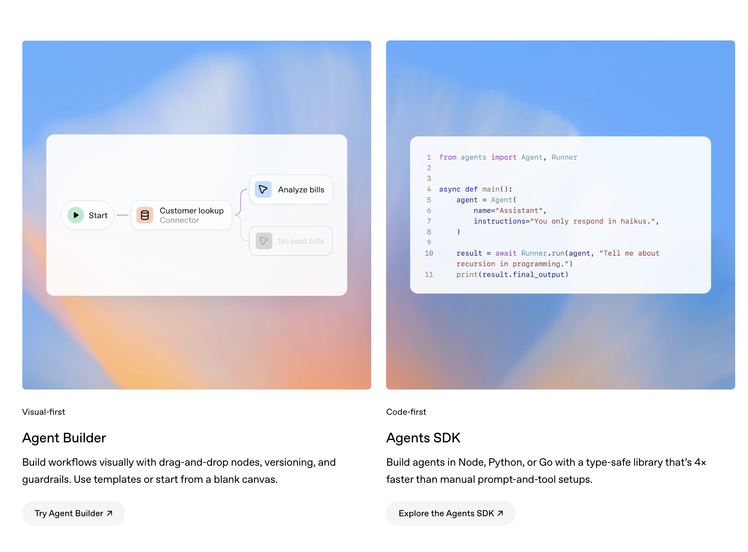

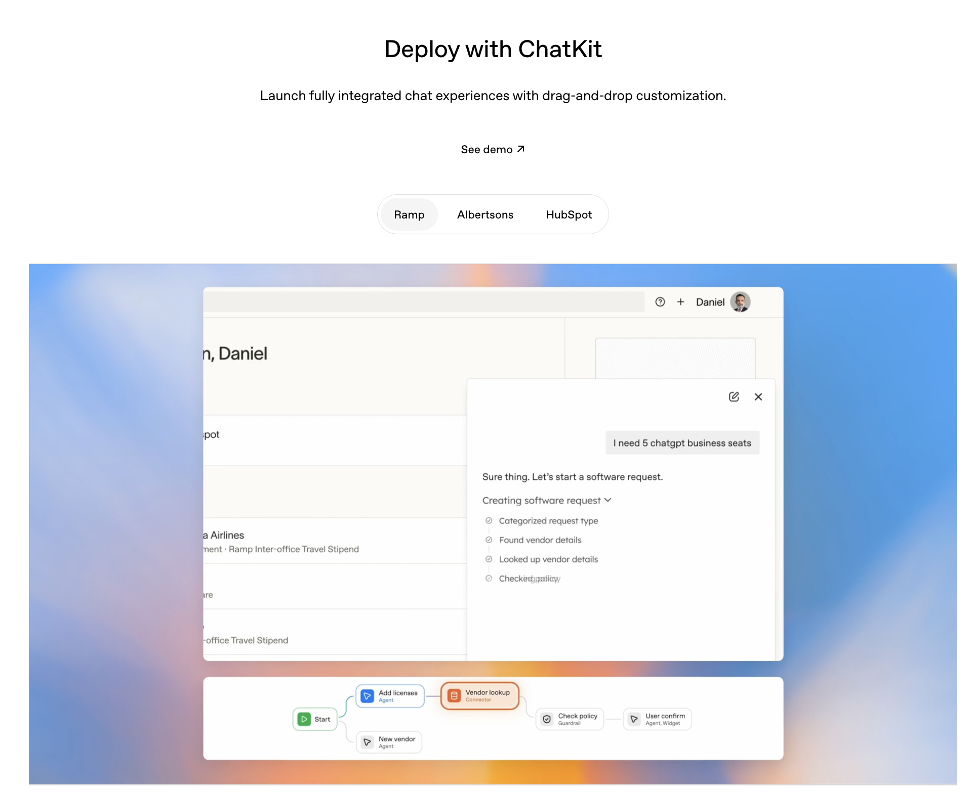

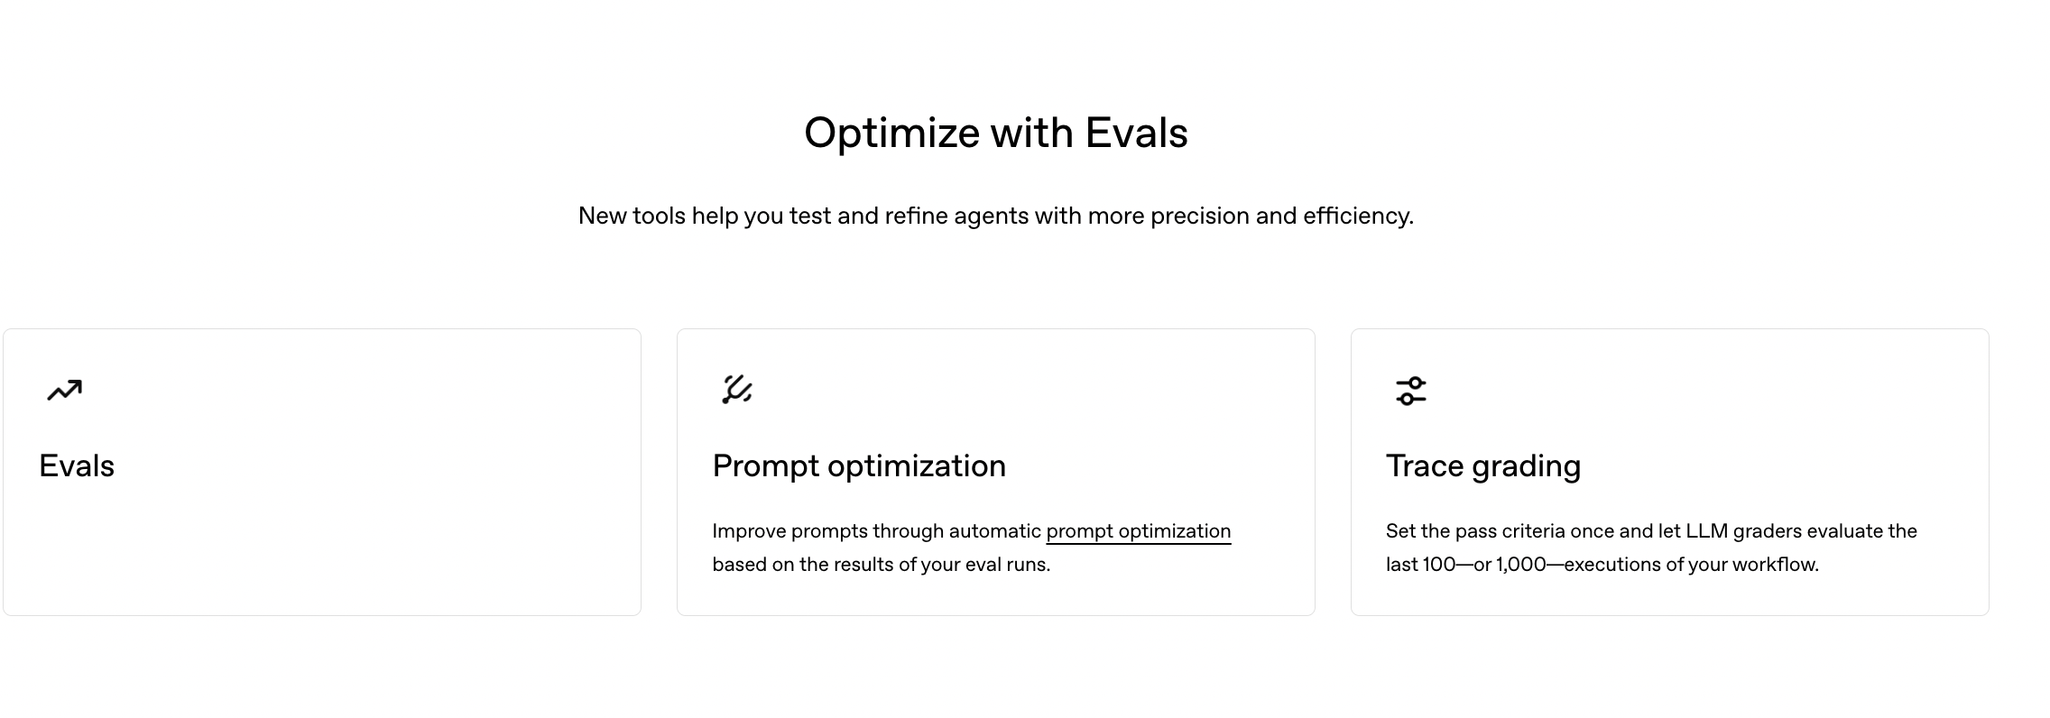

<https://github.com/openai/openai-agents-python?tab=readme-ov-file>

<https://github.com/openai/openai-agents-python/tree/main/examples>

<https://openai.github.io/openai-agents-python/>

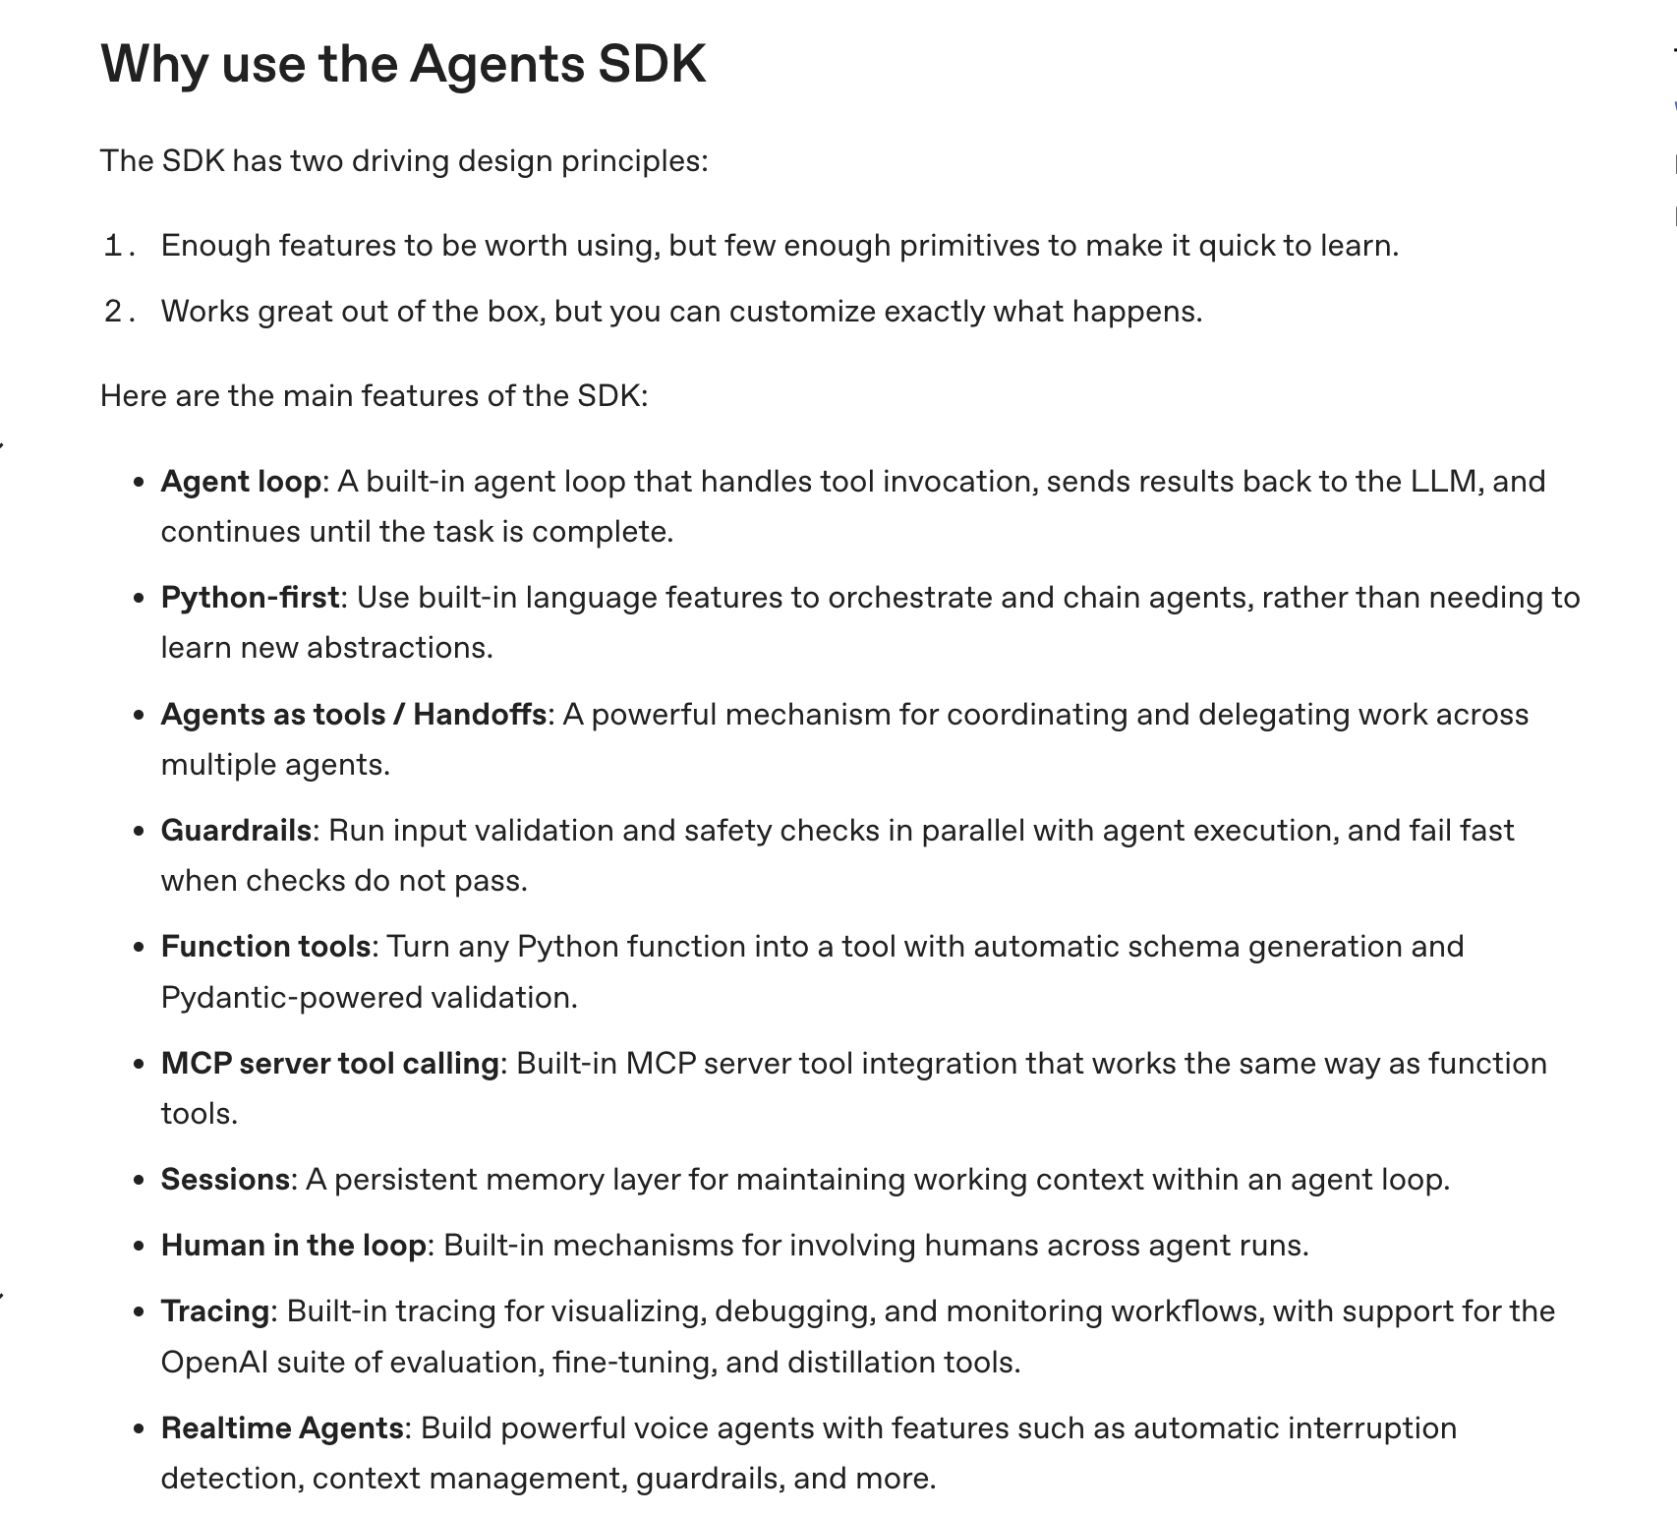

Agents as tools / handoffs = multi-agent architecture where agents can delegate work to other agents just like calling tools.

**Why is it called a handoff?**

Because conceptually it works like this:

One agent **hands over responsibility** for a task to another agent.

Not just “asks for help”, but **transfers ownership of part of the job**.

# FAQ

Once we deploy agent using the Open AI where to deploy ?

**You do NOT deploy your agent “inside OpenAI”.  
You deploy it in your own infrastructure** (your cloud, your VPC, your servers).  
OpenAI only provides the **models + SDK + APIs**, not the hosting of your business logic.

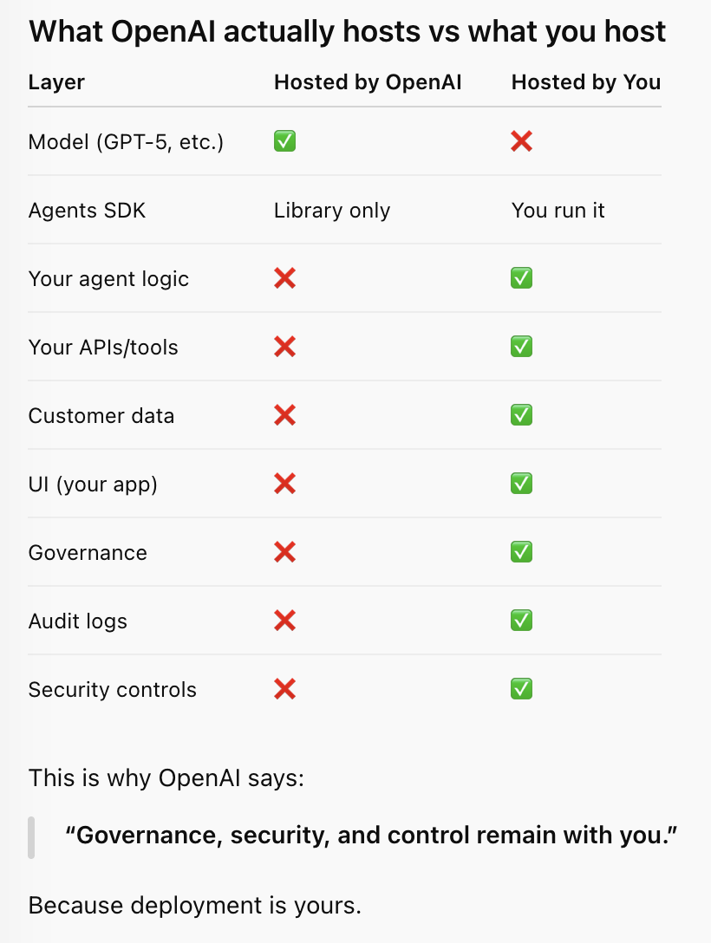

## 

## What ChatKit actually gives you

ChatKit typically provides:

* ✅ Hosted chat UI (web interface)
* ✅ Conversation history UI
* ✅ User authentication (basic)
* ✅ Branding (logo, colors)
* ✅ Drag-and-drop configuration
* ✅ Direct integration with your agent
* ✅ No frontend coding required
* ✅ Fast deployment (minutes–hours)

ChatKit is:

* A **ready-made chat UI platform**
* **Hosted by OpenAI**
* Meant for:
  + Fast prototypes
  + Demos
  + Internal tools
  + Simple production use cases

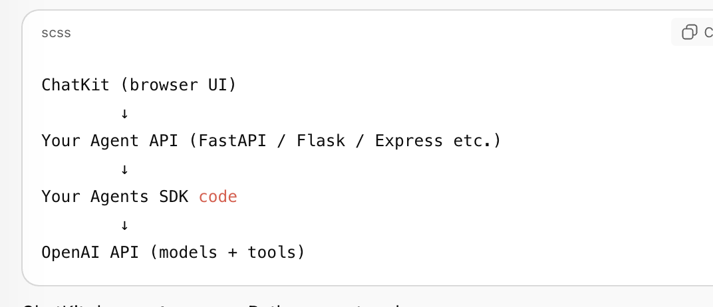

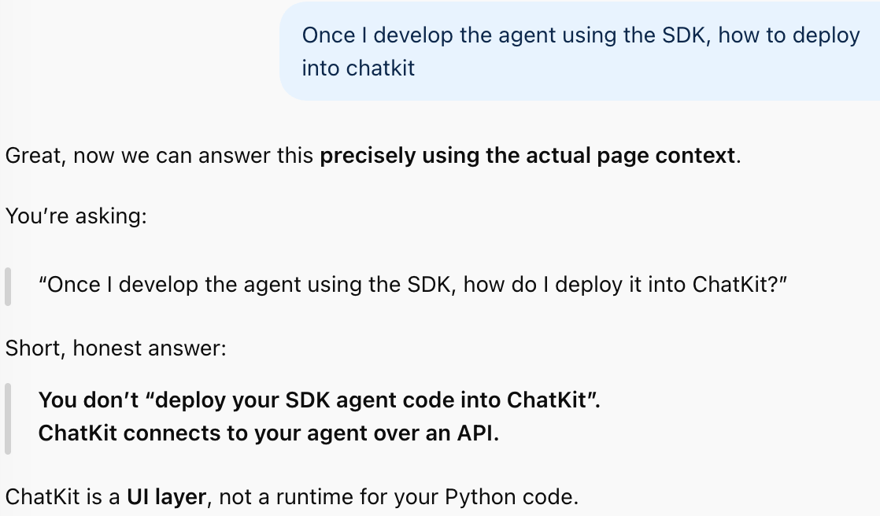

ChatKit is a **hosted product (SaaS UI) provided by OpenAI**, not an open-source package you can deploy inside your VPC.

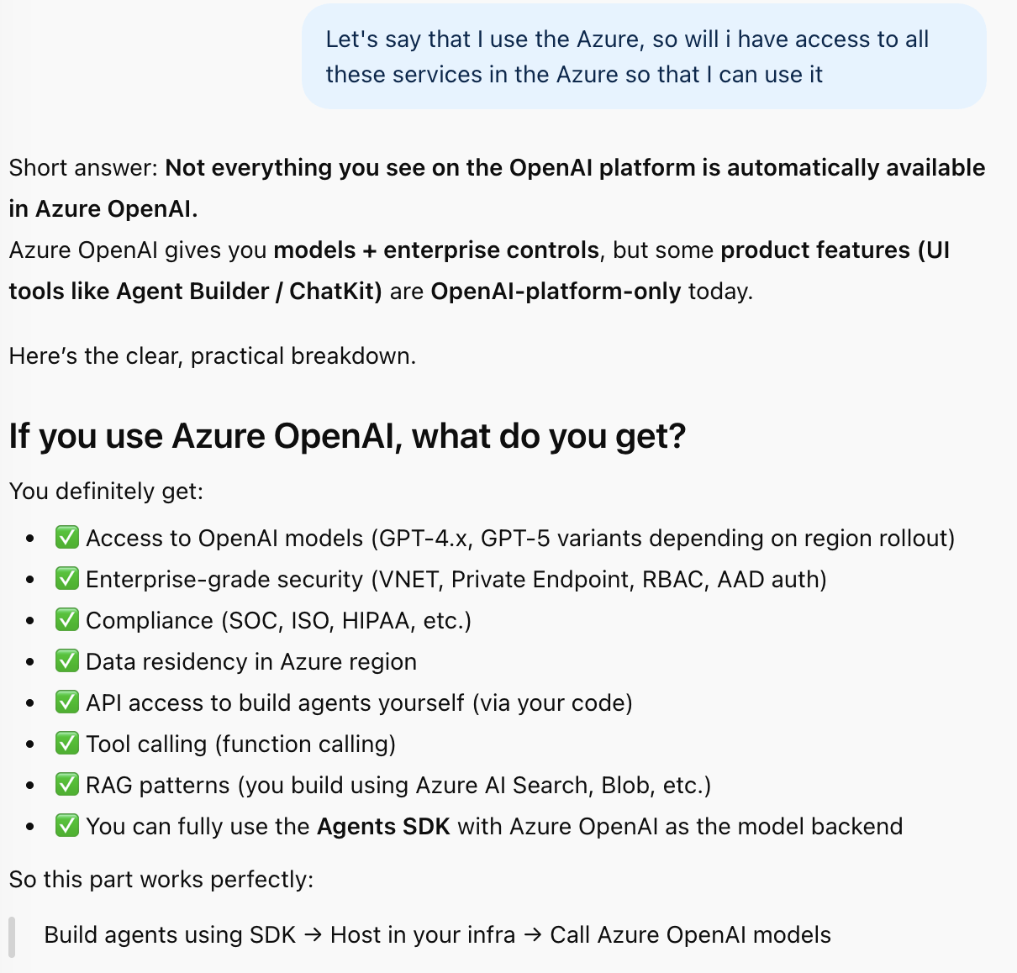

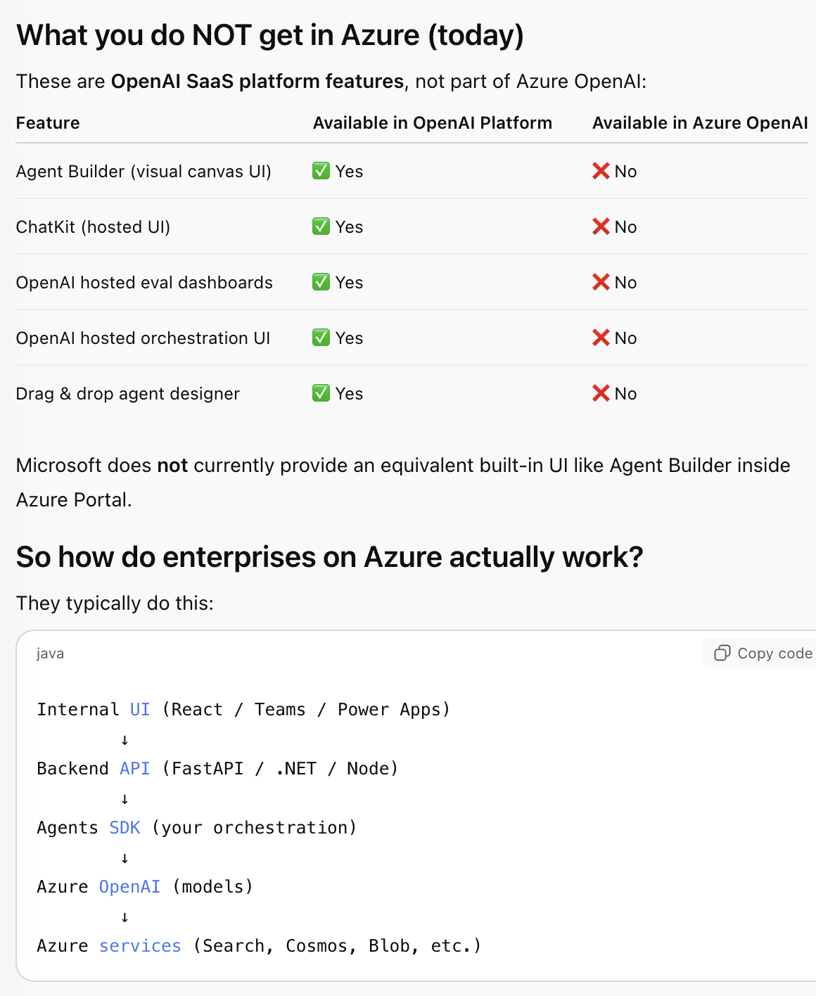

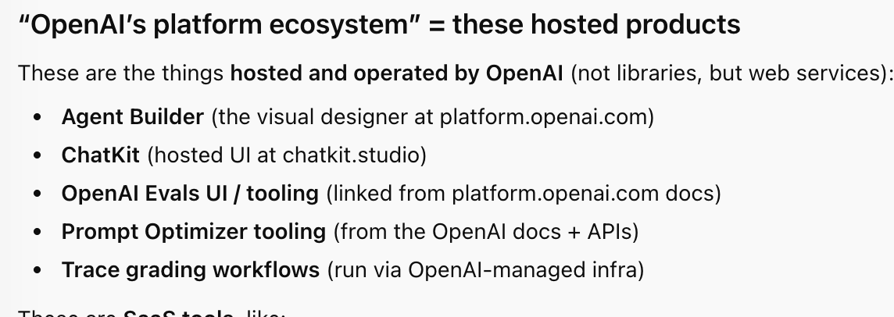

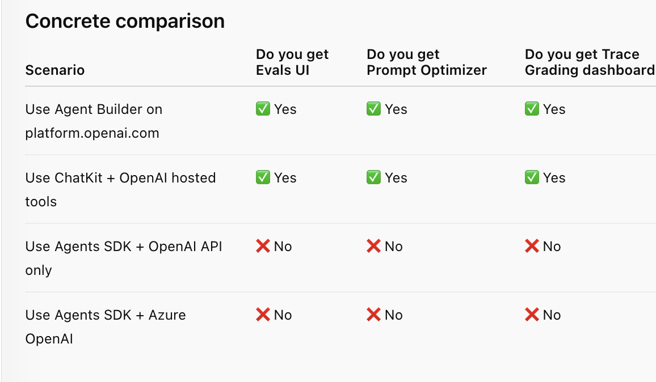

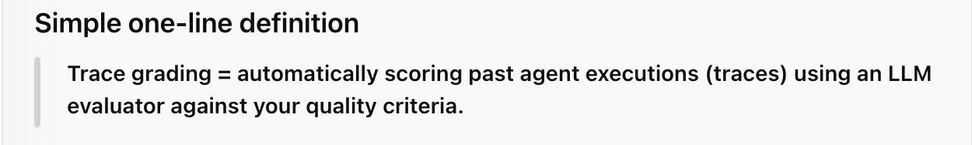

Trace Grading same as overwatch in our tachyon

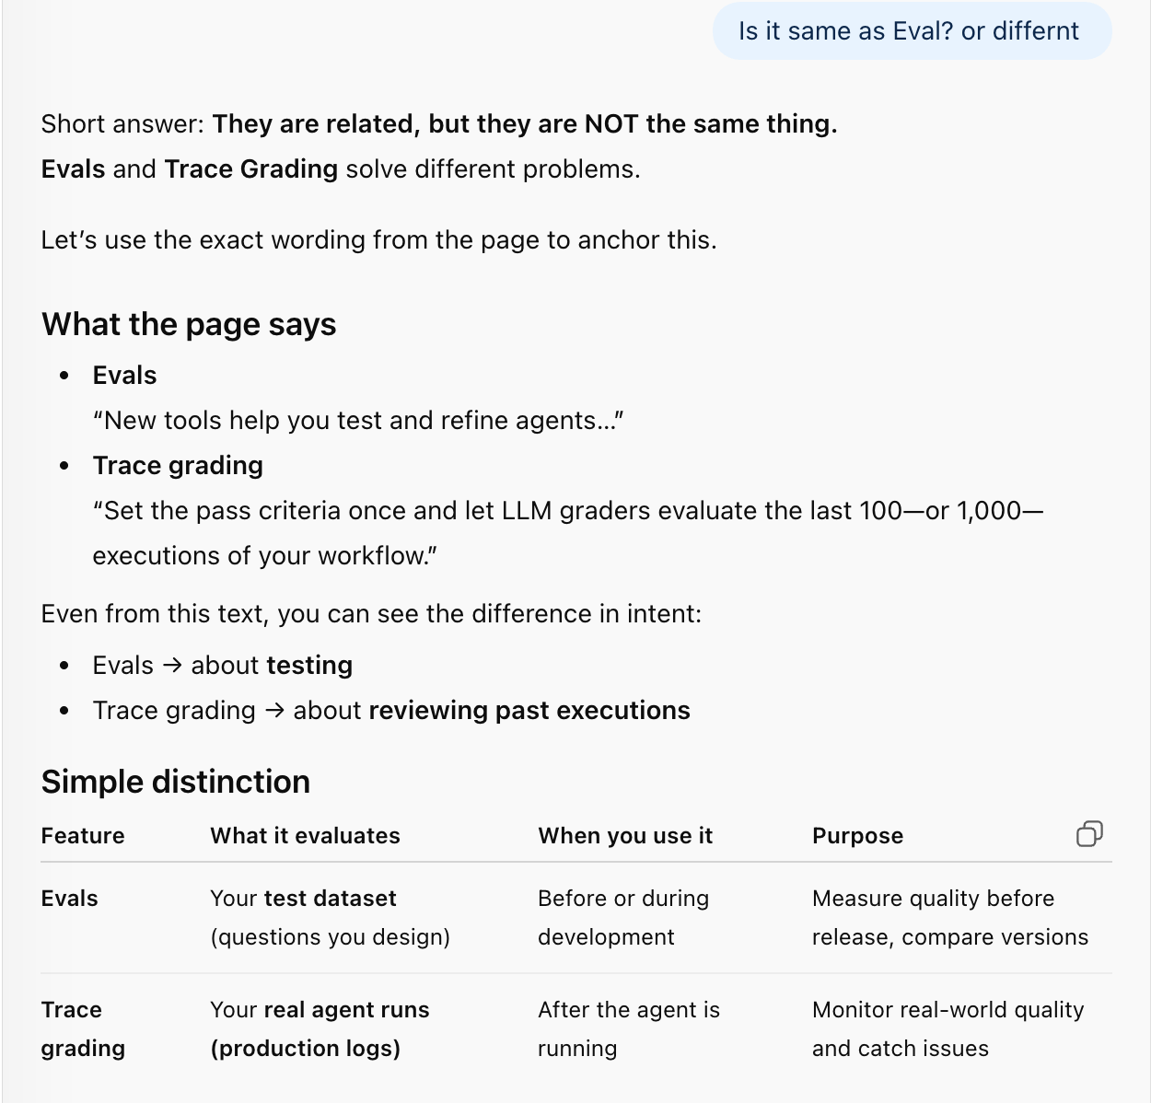

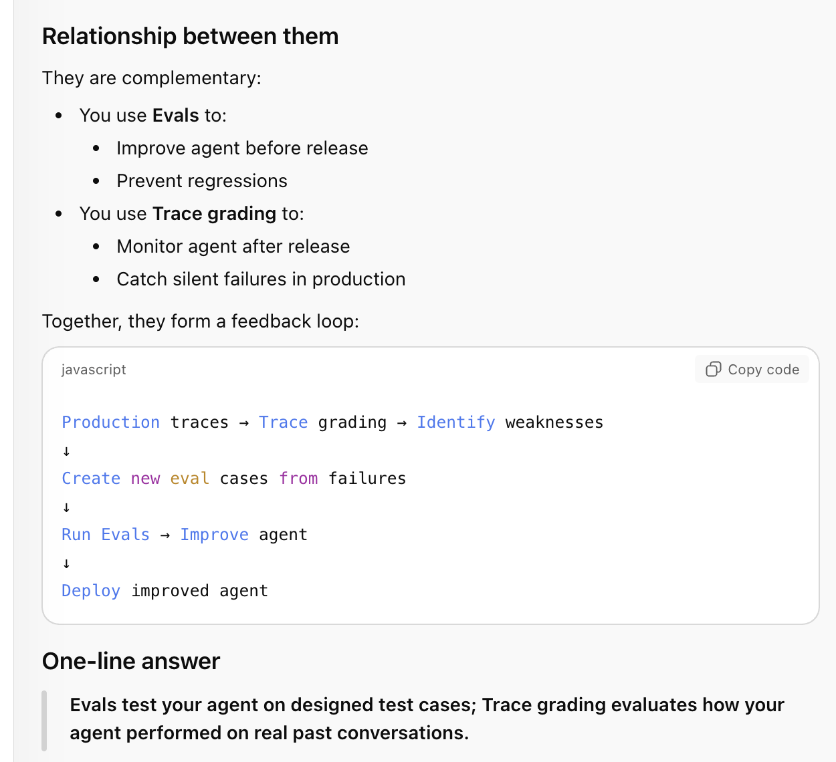

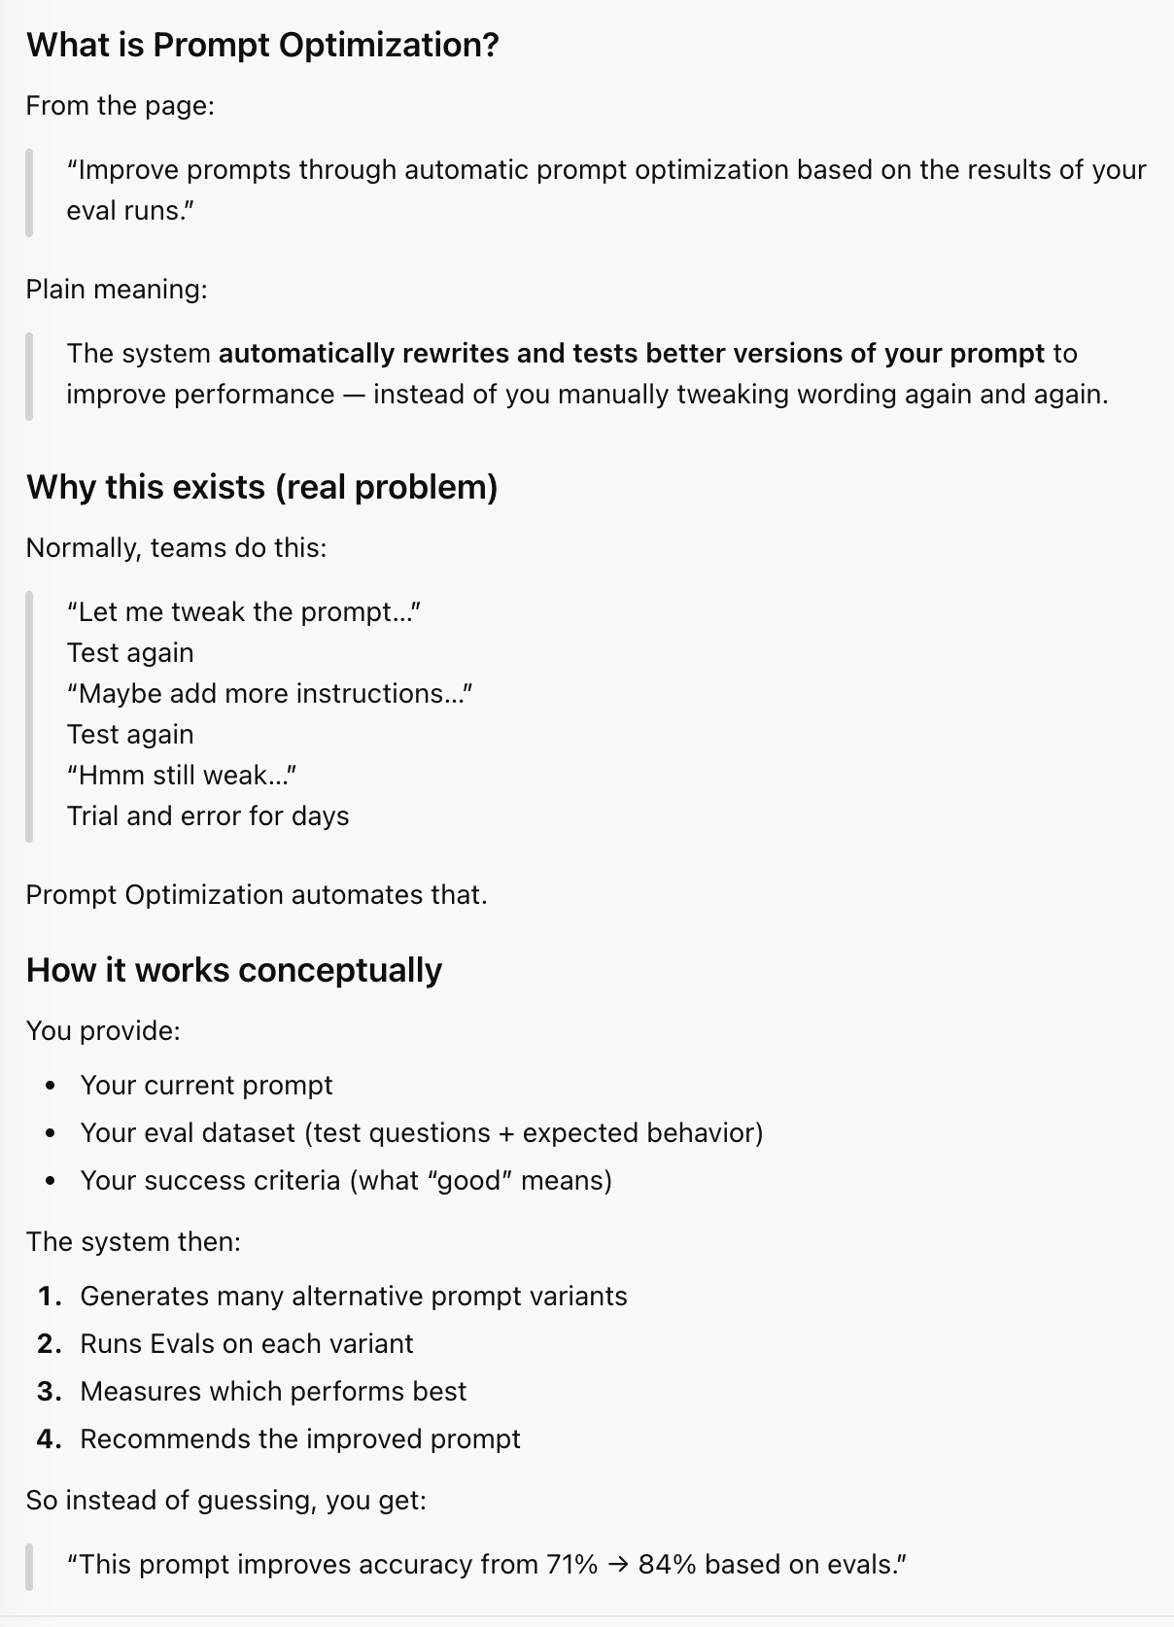

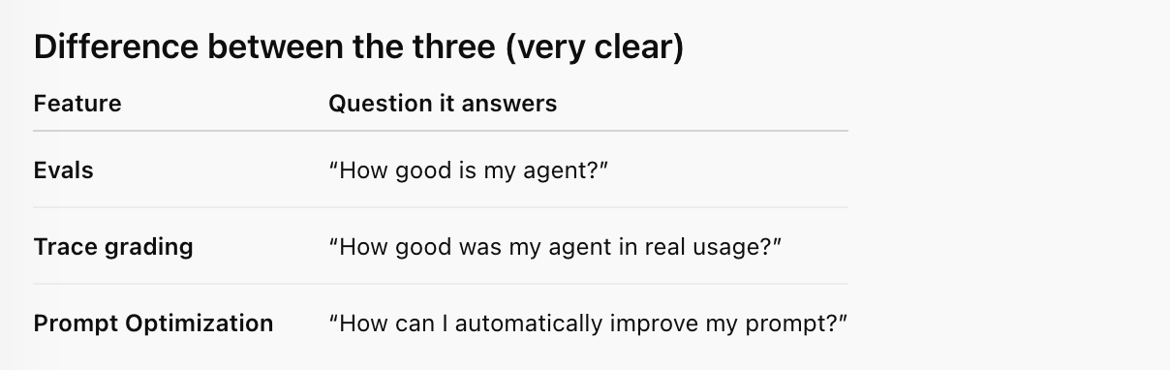

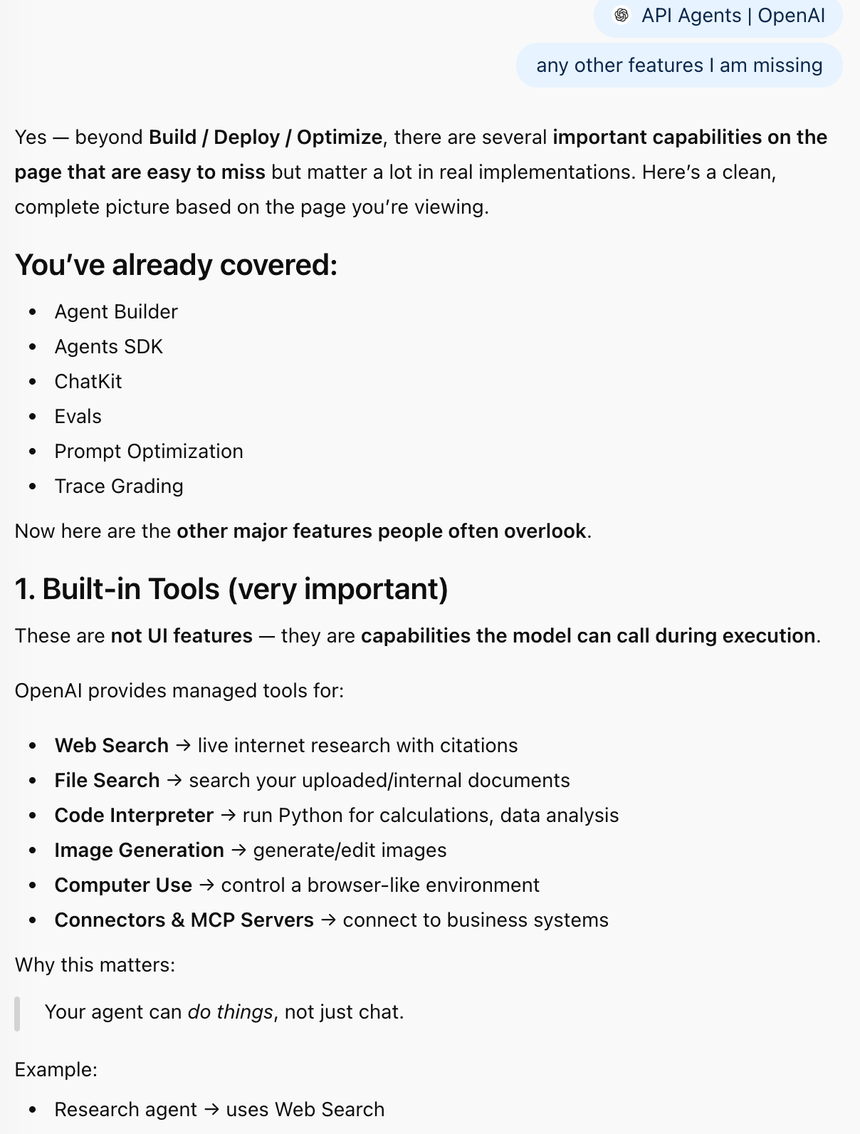

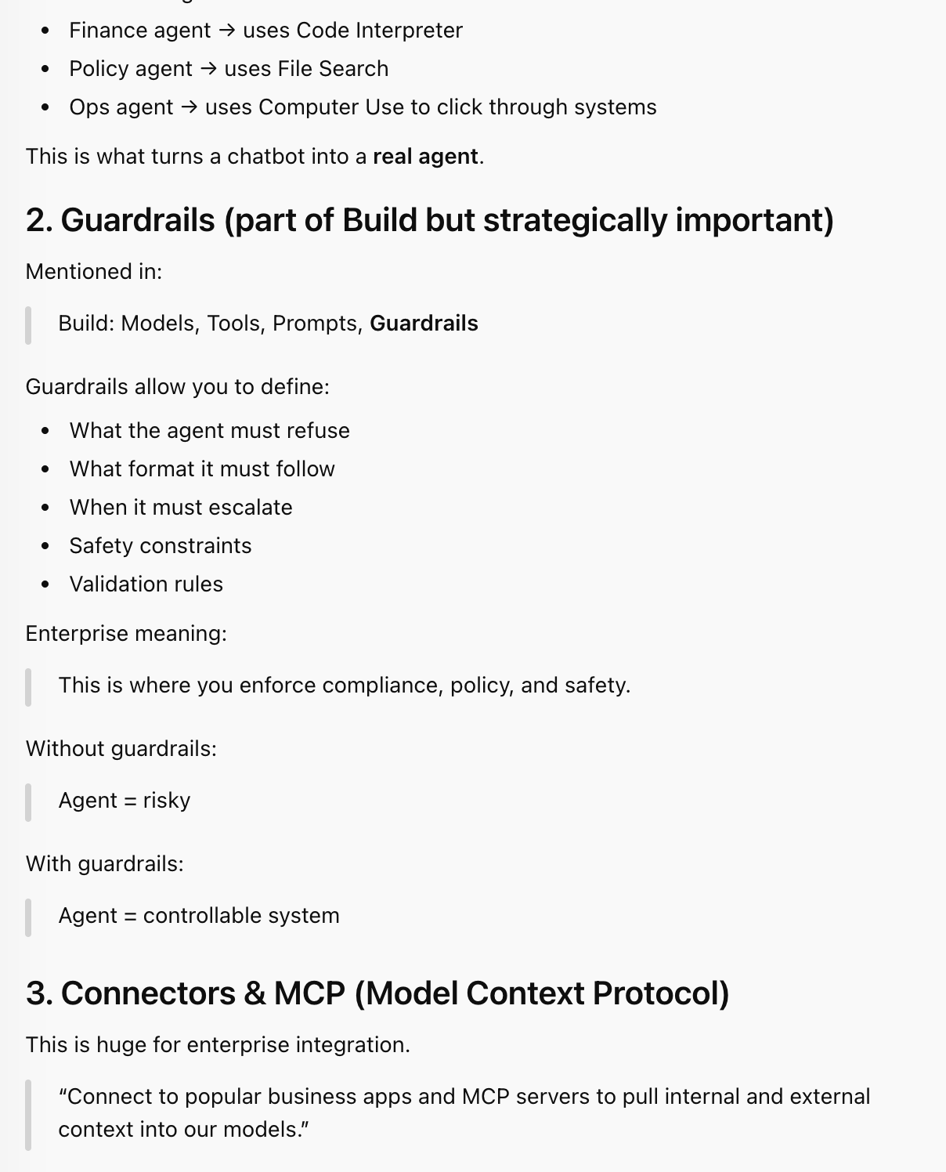

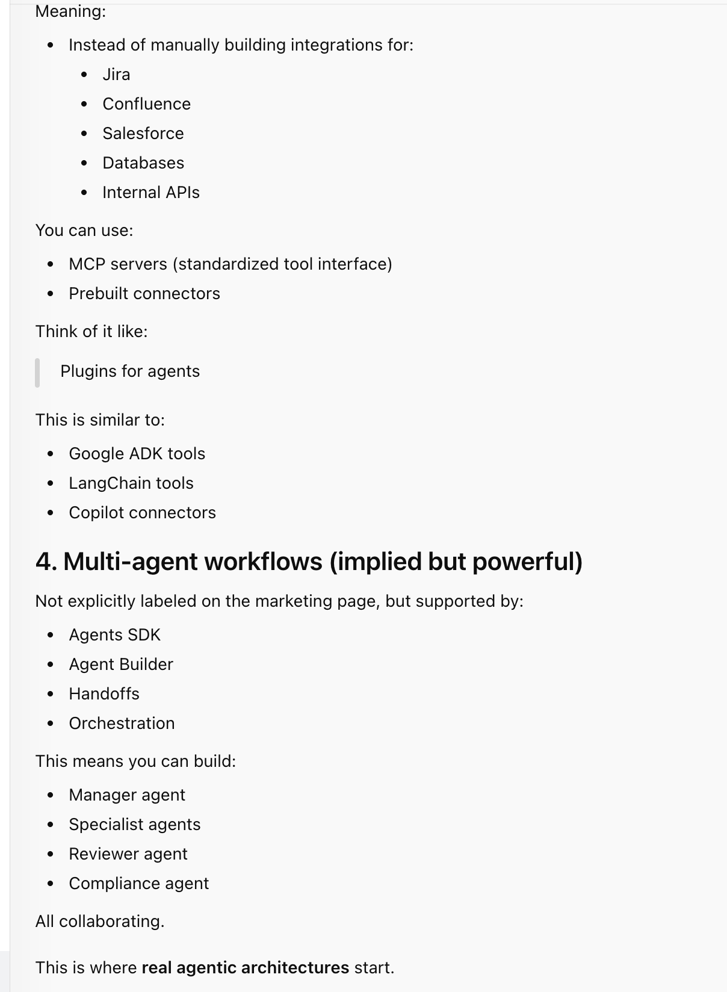

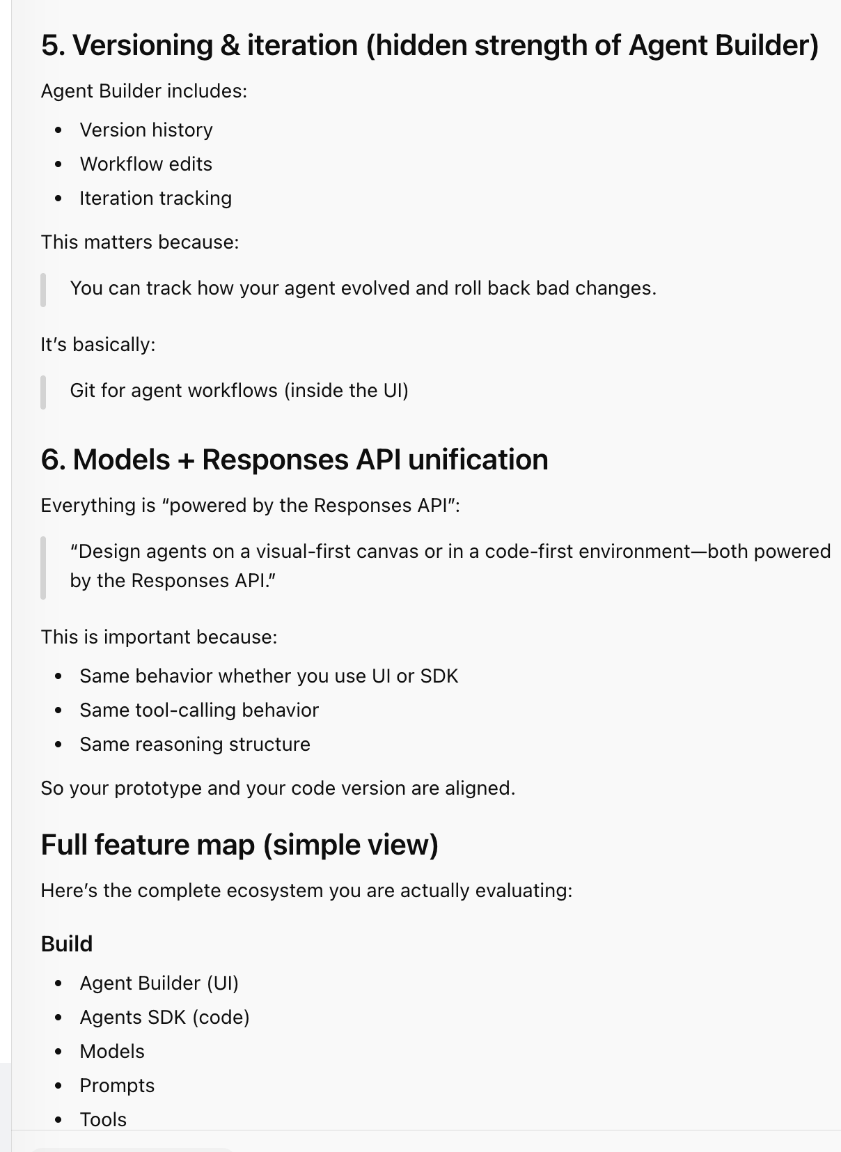

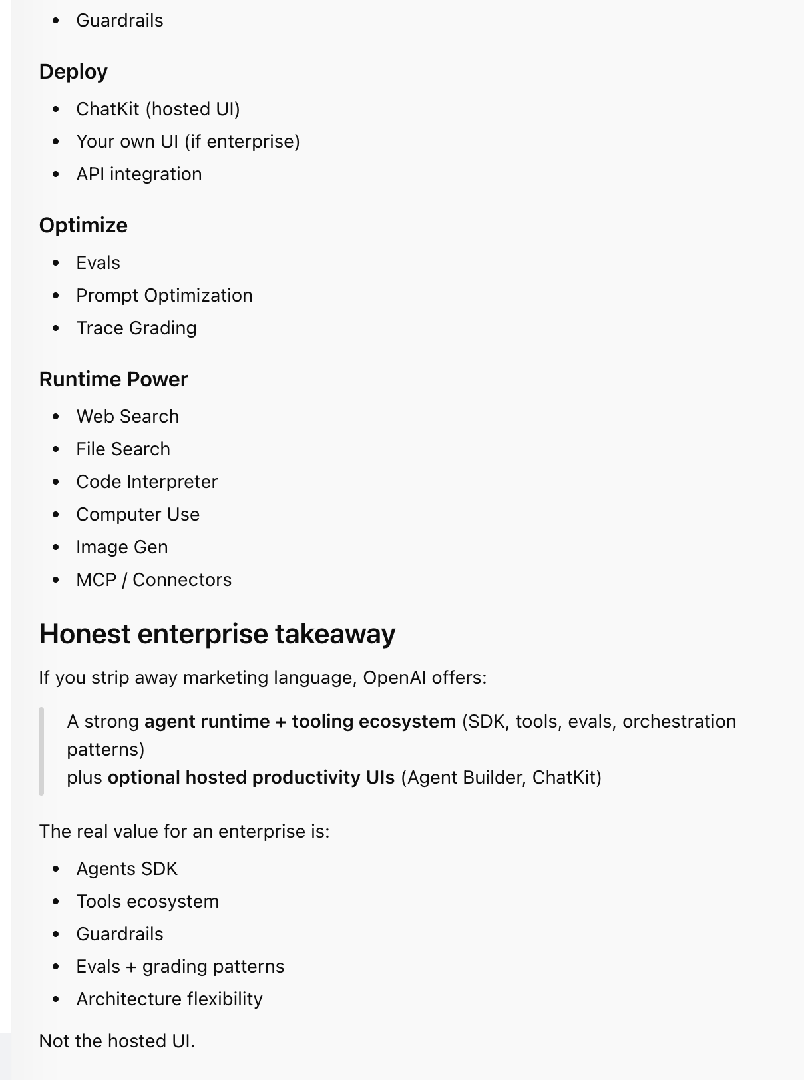

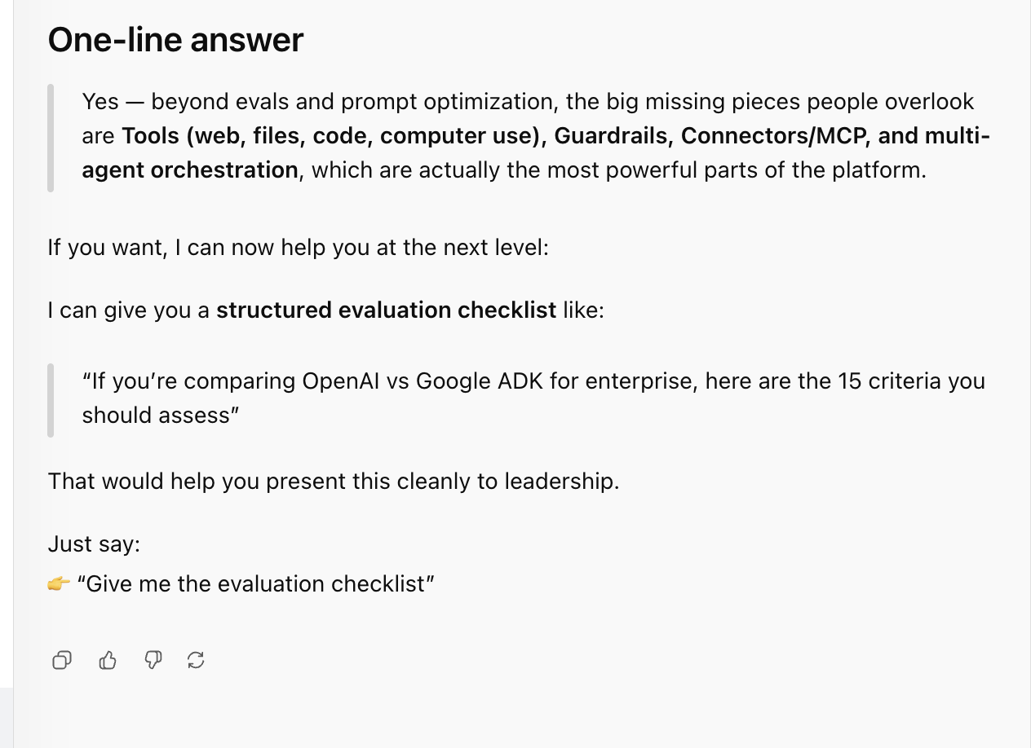

**First: What the ChatKit page actually says (important)**

The docs explicitly say:

**There are two ways to implement ChatKit:**

1. **Recommended integration** – Embed ChatKit in your frontend, **let OpenAI host and scale the backend** (Agent Builder workflows)
2. **Advanced integration** – **Run ChatKit on your own infrastructure. Use the ChatKit SDK and connect to any agentic backend.**

